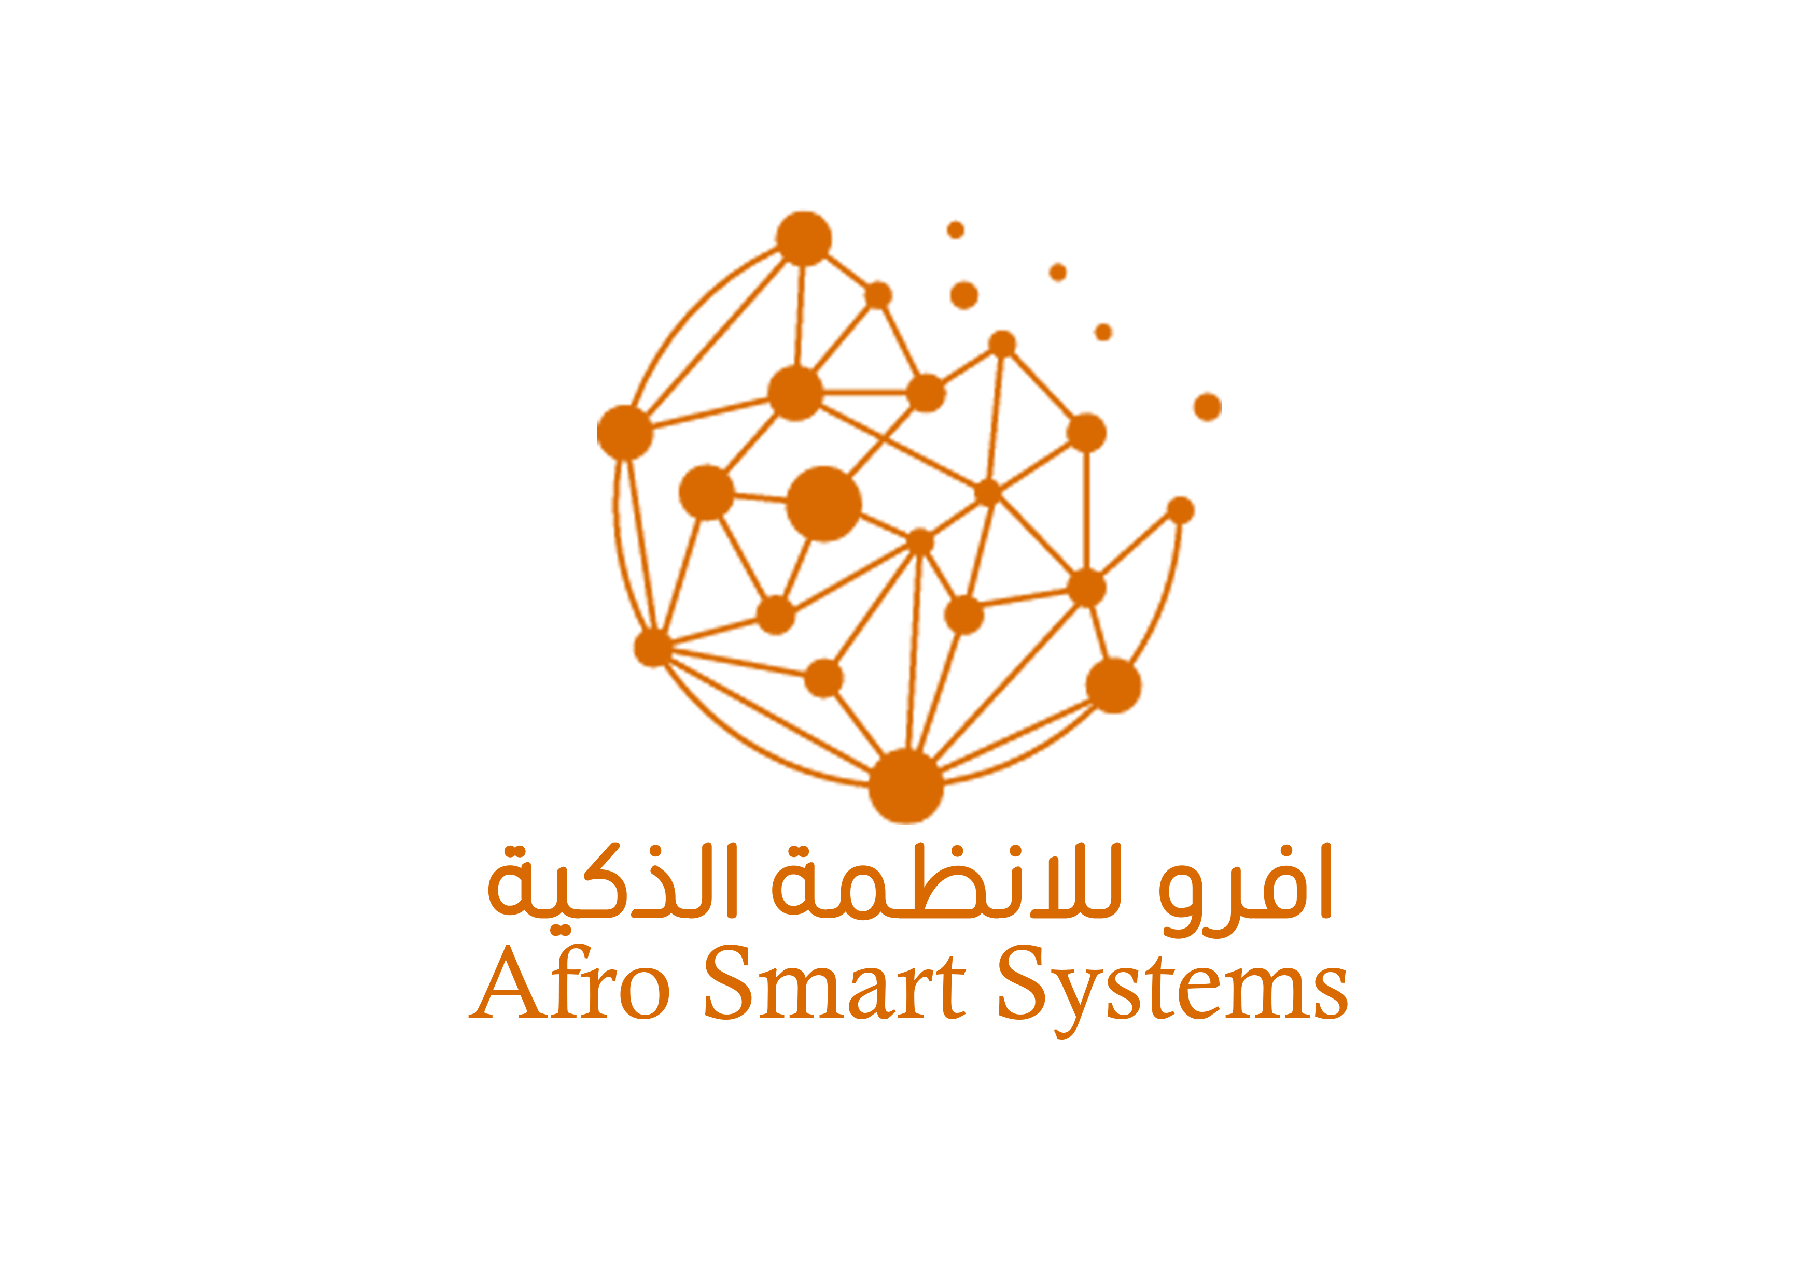

**Afro Smart System**

1. How we are ………………………………………………………………………………………………………………………………
2. Our vision ………………………………………………………………………………………………………………………………….
3. Our mission ……………………………………………………………………………………………………………………………….
4. Our massage……………………………………………………………………………………………………………………………..
5. Our services ……………………………………………………………………………………………………………………………..

* **Who are we?**

Experts and professional engineers in building professional systems with excellent start and we have the ability to provide professional technical solutions in the field of management systems, networks and protection systems.

* **Vision**

Building successful projects in light of development and enhancing society with the best technologies.

* **Goal**

Achieving the best successes as much as possible to satisfy our valued customers

* **Message**

To make a difference in the local and global community through the best technologies.

**Our services**

**1-Integrated cashier systems Pharmacies - Restaurants - Stores**

Cashier systems have become very important for private business owners as they facilitate the printing of sales and purchases, warehouse management, an integrated billing system, and monthly sales and warehouse reports.

**2-Design and maintenance of network systems**

Networks and network management have become a priority for any institution. Network systems have become very important for companies and organizations as they facilitate the process of completing tasks with ease.

**3-Design and maintenance of computer laptops.**

This is a service we provide specifically for universities, training centers and schools, which helps them in the process of keeping their devices updated with the latest technologies and cutting-edge options to ensure high-efficiency work without malfunctions.

**4-Installation and maintenance of surveillance cameras.**

Security systems have become very important at the present time as they make the process of printing work or establishment with ease and from anywhere in the world

**6-Installation of attendance and departure systems.**

This service has become one of the regular systems in universities, schools, companies and factories, as it guarantees the right of the owner and employee to administrative work with accuracy and transparency.

**7-Installation and maintenance of servers**

Every integrated institution must work on servers to facilitate the communication process and share information and data to increase the efficiency of production and achievement.

**8-Control systems and smart gates**

The smart system has become part of every advanced institution. It is one of the best security systems that work to control doors and gates, allowing entry by password, card, fingerprint or face.

**9-Website design**

The importance of designing a website lies in providing a unique means of communicating with the world. To share your interests, inform people about your work, or sell and market your products, it guarantees the development of your business with increased sales.

**10-Cooling and air conditioning services**

The importance of this service includes the work of cooling devices with high sufficiency in terms of correct installation, cleanliness, maintenance and periodic follow-up.

11- FRP Management Systems Design

Management systems are systems that benefit business owners and organizations by facilitating the work of all employees and administrative staff within one platform and from anywhere in the world.

12**-Hosting and Domain Services**

**1-The domain name is the address of your website on the web. It identifies the website and allows people to find it through browsers.**

**2-Hosting is where your website files are kept.**

**Hence the importance of the domain name and hosting. This is a very important service for companies and organizations as it ensures the preservation of emails, web files, systems and any other data.**